Subject: Trust Bravecto® to keep you closer for longer with your pets
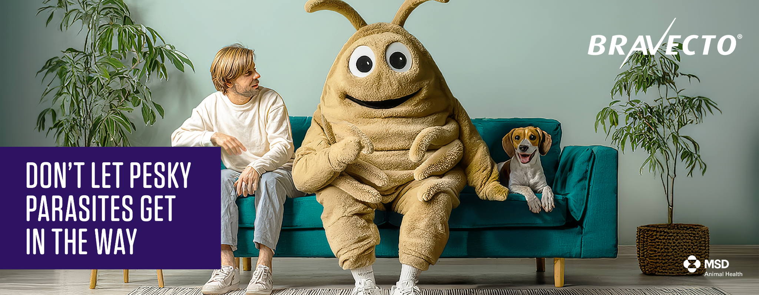
Nothing should come between you and your pet, especially those pesky ticks and fleas. With just one dose, Bravecto® provides 12 weeks of protection, so you can enjoy more cuddles, more play, and more uninterrupted moments together.
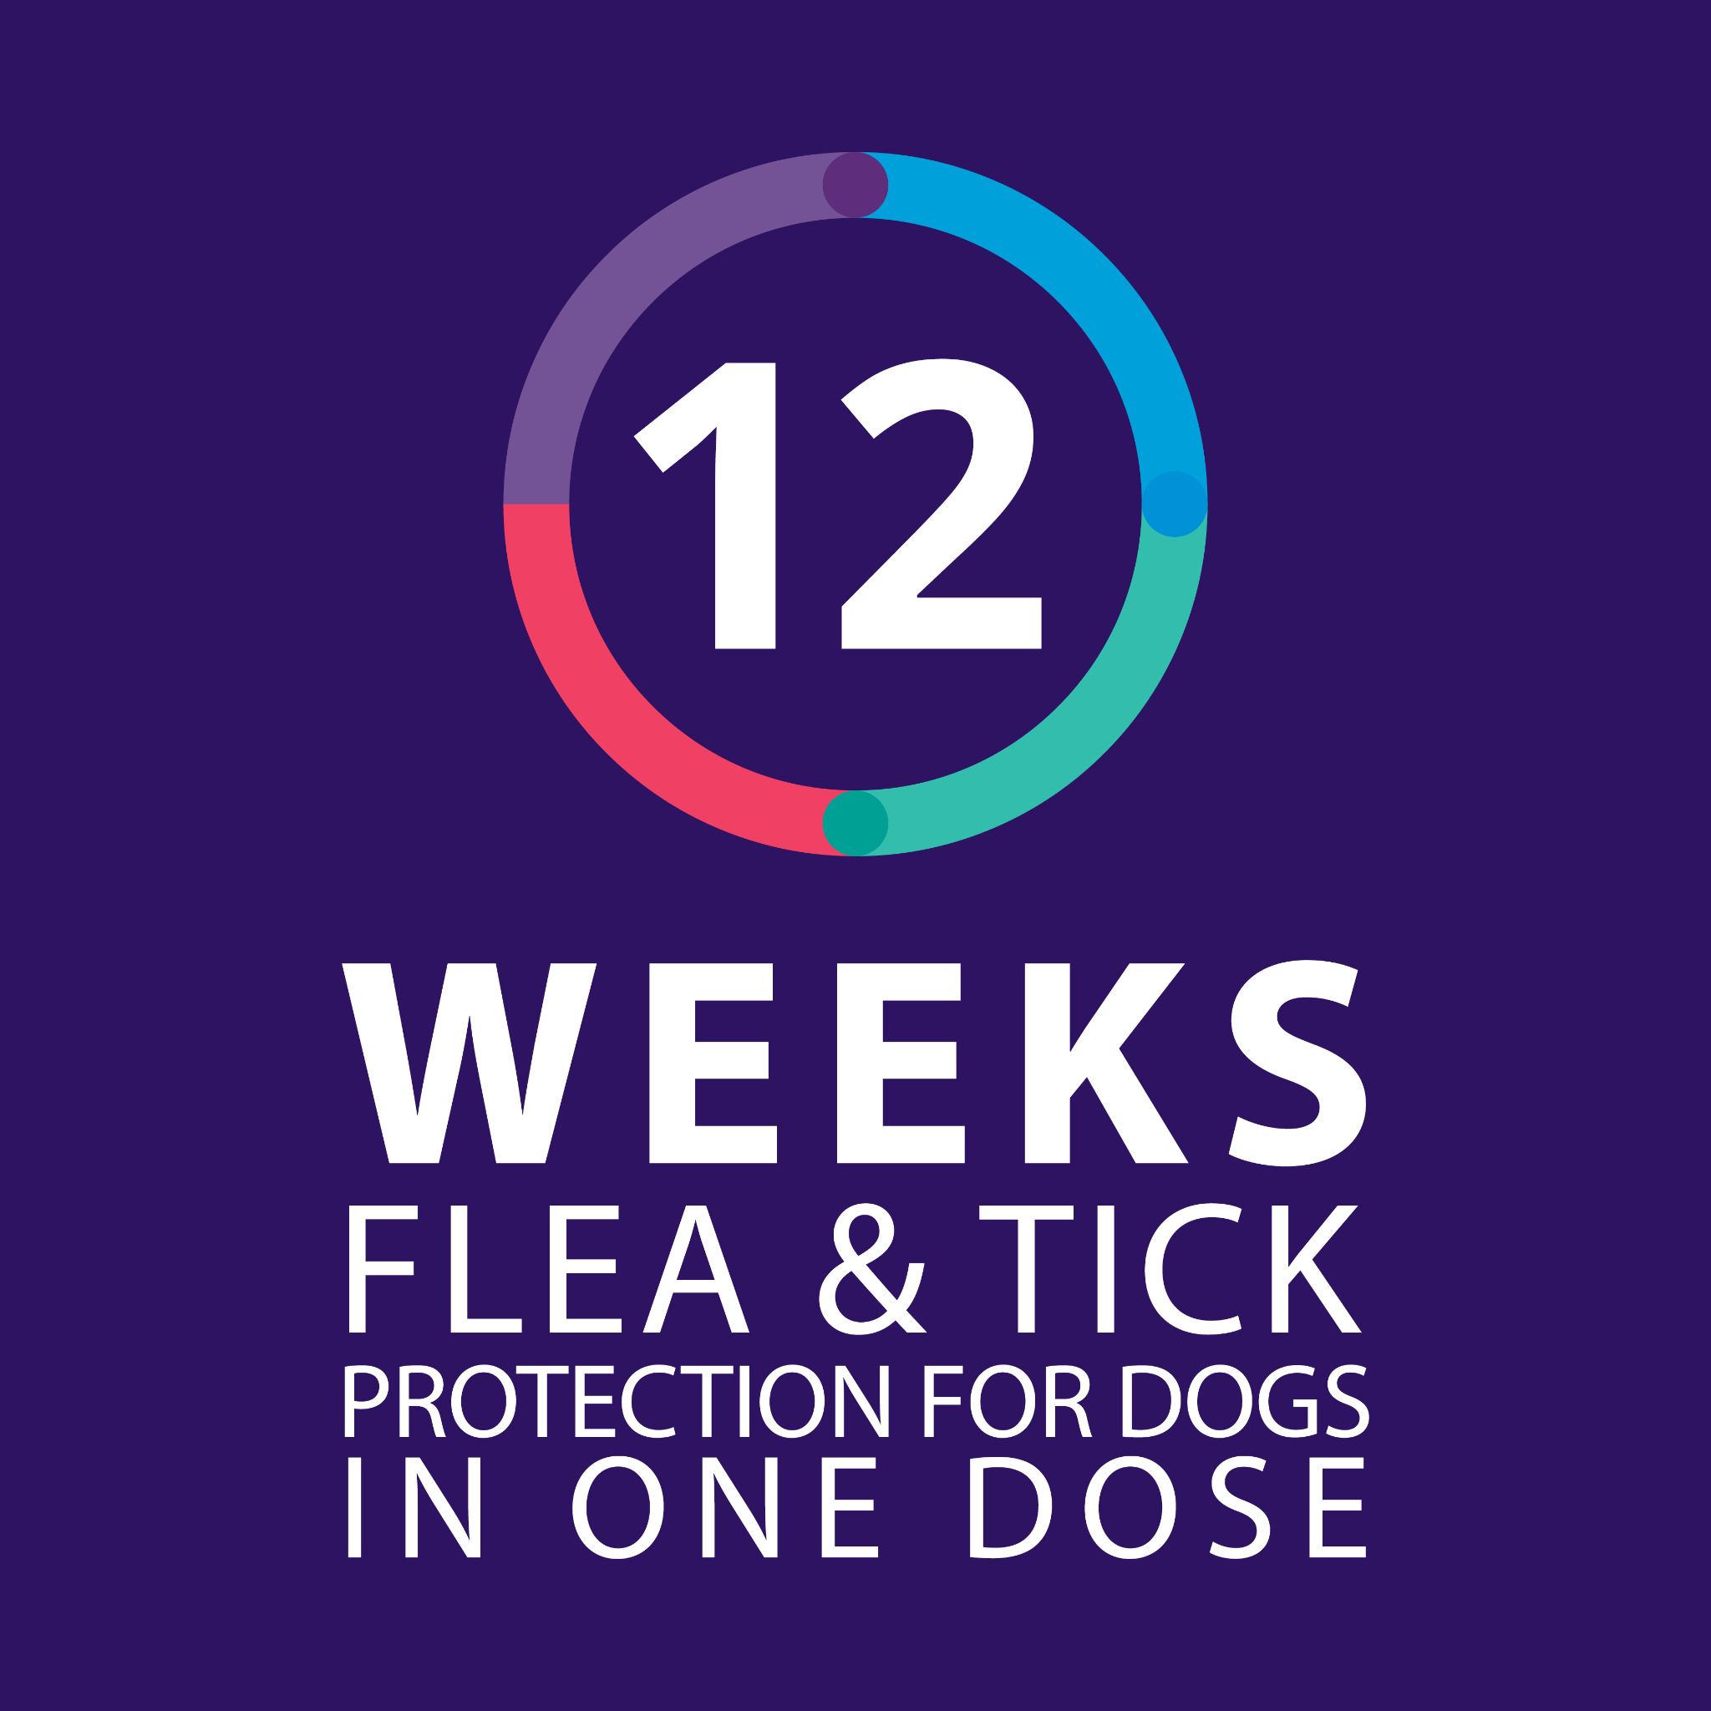
Why long-lasting protection matters
Ticks and fleas don’t just live on your pet,
they lay eggs that spread into your home
and environment, continuing the cycle.
Breaking that cycle is key to keeping your
pet comfortable and protected, and it takes
consistent, long-lasting protection to do
it effectively.

Learn more about protecting your pet
Click here [https://www.bravecto.co.za/flea-and-tick/] to discover how Bravecto® helps break the
tick and flea cycle and keeps your pet
protected for longer.


Our long-lasting protection now means even more!
We know our pets live active and full lives and sometimes unforeseen things happen. When you buy Bravecto® you could unlock 3 months free pet accident benefits with Brave-Protect.
📱 Download the Bravecto® Rewards & Reminders app
🛒 Make at least one Bravecto® purchase
💜 Receive a virtual stamp in the app
✅ Register for your Membership Benefit on our website [www.bravecto.co.za/brave-protect/]

[Button: App download deep-link]

Warm regards,
The Bravecto® Team

ZA-BRV-260300009
Intervet South Africa (Pty) Ltd | Reg.No 1991/006580/07
20 Spartan Road, Spartan, 1619, RSA | Private Bag X2026, Isando, 1600, RSA
Tel: +27 (0)11 923 9300 | www.msd-animal-health.co.za
BRAVECTO® Reg. No. G4083 (Act 36/1947) Contains minimum 25 - 56 mg Fluralaner per kg body weight
BRAVECTO® SPOT-ON Reg. No. G4292 (Act 36/1947) Each 1 ml of Bravecto® Spot-On contains 280 mg fluralaner
BRAVECTO® PLUS Reg. No. G4408 (Act 36/1947) Each 1 ml contains 280 mg fluralaner and 14 mg moxidectin

