Subject: One dose of Bravecto® for spring. 12 weeks of protection.

Spring is made for more walks, more play, more adventures and more lounging around with your pet, not ticks and fleas. With just one dose, Bravecto® provides 12 weeks of protection, helping your pet stay protected throughout the spring season
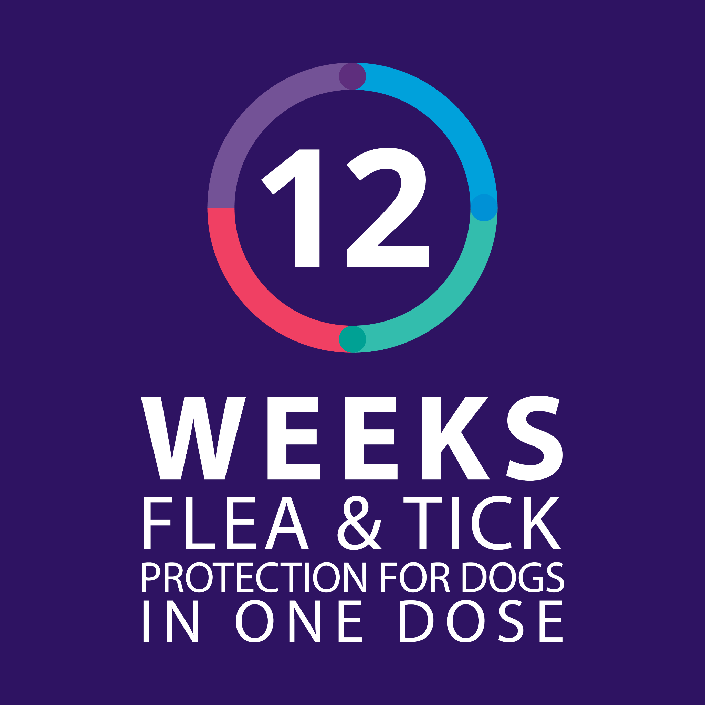
Why long-lasting protection matters
As the weather warms up, ticks and fleas become more active. Consistent, long-lasting protection helps break their life cycle and keeps your pet comfortable, protected and ready to enjoy every spring moment with you.

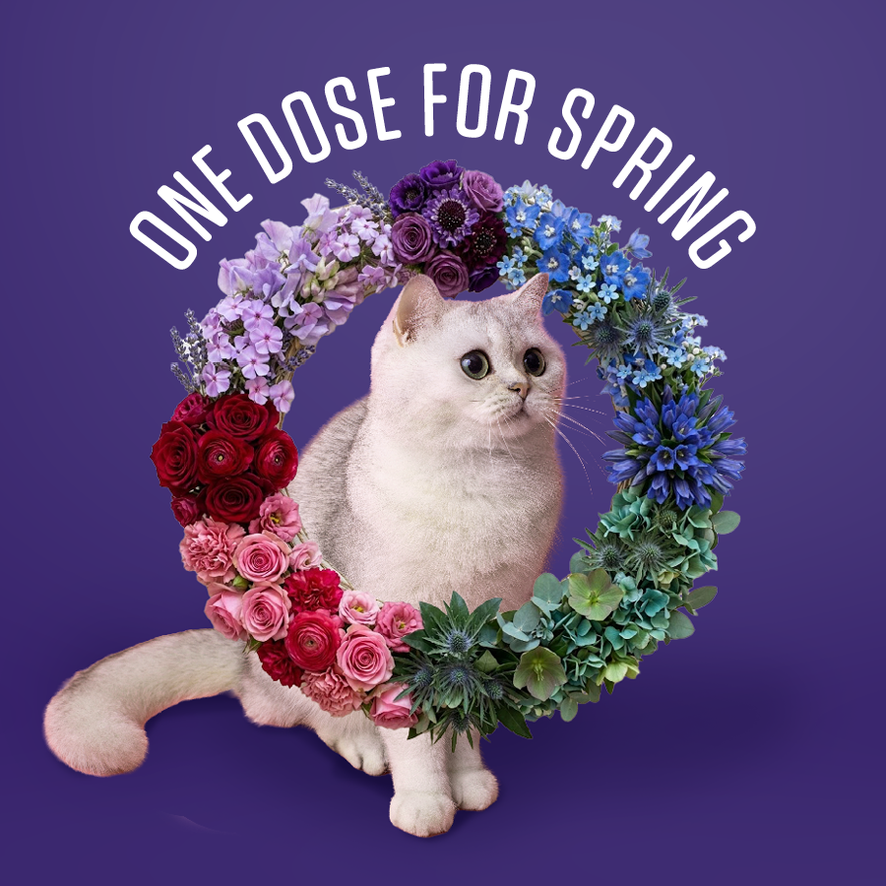
Learn more about protecting your pet
Speak to your specialty pet shop or veterinarian about Bravecto® or click here [https://www.bravecto.co.za/flea-and-tick/] to learn more about long-lasting tick and flea protection.

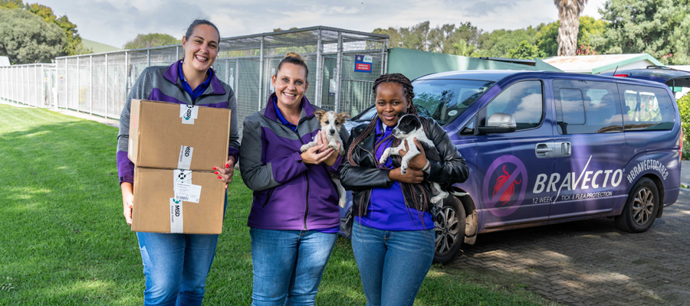
Bravecto® Cares for SA’s Shelter Dogs
Through our #BravectoCares initiative, this winter 21,500 doses of tick and flea treatments valued at R7 million were sponsored to animal shelters across South Africa, helping thousands of vulnerable dogs live happier, healthier lives.
Read the full Good Things Guy story [https://www.goodthingsguy.com/bravecto-team-support-sa-shelters/] and discover how long-lasting protection is making a meaningful difference.


Warm regards,
The Bravecto® Team

